Add a Fixed Asset (FD) Disposition (Retirement)

The following instructions will provide the minimum requirements for retiring a fixed asset record for a vehicle.

NOTE: For Spending Units exempt from Surplus Property, please make sure that your wvOASIS Security for FD’s is at a 3 Level Approval and not a 5 Level Approval in the Workflow of the document.

Navigate to the Document Catalog and create a FD document <OR> JUMP TO = FD

Type the code: FD
Type your department number
Type your unit number
Click Create

Click the Auto Numbering box and click Create

HEADER/General Information

Fixed Asset Number Type the unique A number associated with the asset you want to retire

Document Name Type a comment or information for your purposes

Auto Apply Click Auto Apply in the bottom right hand section of the screen. The fixed asset description will populate.

Click SAVE

HEADER/Disposition Information Tab

Disposition Date Type the date of the disposition (retirement) of this vehicle

Disposition Method Select the appropriate disposition method:

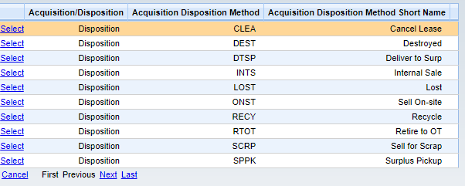
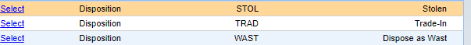

Disposition Authority Type the condition for the asset. Fair is suggested for sold/DTSP vehicles.

NOTE: For Spending Units that are exempt from Surplus Property, please attach both the Bill of Sale and Executed Title to the Header. If you are claiming an asset as LOST, please attach a signed, dated letter explaining everything you did to try and find the asset (physical inventory, talked to the custodian, etc.). This letter should be signed by a Director or equal of the Spending Unit. Address the letter TO WHOM IT MAY CONCERN at Fleet Management Division.

Fair

Click SAVE
Click VALIDATE

If no errors exist, you can click SUBMIT and the FD document can be approved.

