Last 5 digits of Fuel Card #

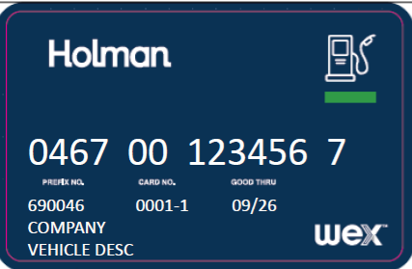
Agency Bill Code
Last 6 of VIN (Vehicle#)
Card Exp Date
AGENCY/OFFICE
Agency/Dept Name

Holman Fuel Card Reference Sheet

Please keep with Reference Sheet with the Fuel card in vehicle.

Each Holman fuel card is assigned to a specific vehicle and should remain in the glove box of that vehicle. It is to be used for the purchase of fuel only and for that assigned vehicle only. No other purchases are to be made with it. Also, car washes should not be facilitated at the pump. Car washes can only be facilitated through Holman’s maintenance services. Also, any maintenance supplies needed should be purchased by an alternative method instead of the Fuel Card.

To use the Fuel Card, you are required to obtain a PIN Number. The PIN number can be assigned to you by either your AFC or Manager. If renting a vehicle from the Fleet Management Division, a PIN Number will be assigned to you by the Fleet Management Division if you do not already have one. Please remember your PIN Number is not to be shared with anyone. You are responsible for your own PIN number.

Per Legislative Rule §148-3-12.2.c: All fuel purchases must be for regular unleaded or diesel unless a higher grade or other type of fuel is required by the manufacturer. Any exception must be requested in writing by the spending unit and approved by the Fleet Management Division.

How to use the Fuel Card when Fueling the Vehicle

NOTE: Before you shut off the engine, please take note of your odometer reading. You will need to enter this at the pump when prompted.
- Swipe the Holman fuel card.
- When asked for the Odometer, enter the correct odometer reading from the vehicle. (Note: This is not your PIN Number)
- Next, enter your 6-digit PIN Number.
- Select the fuel grade (87% level) and pump fuel.
- Always remember to get a copy of the receipt at the pump or from the cashier for your agency for billing.

If you have any issues with your card at the pump, have the cashier run it. If you are still having issues, then you will need to contact your AFC or manager. If you are unable to reach your AFC or manager, please contact Holman at 1-800-CAR-CARE.

