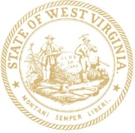 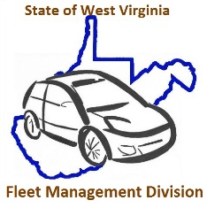

STATE OF WEST VIRGINIA

**DEPARTMENT OF ADMINISTRATION**

**Kenny H. Yoakum**

**DIRECTOR**

**Allan L. McVey**

**CABINET SECRETARY**

**FLEET MANAGEMENT DIVISION**

2101 WASHINGTON STREET, EAST

P.O. BOX 50121

CHARLESTON, WEST VIRGINIA 25305-0121

8/7/2020

Cabinet Secretary, Allan McVey

West Virginia Department of Administration

1409 Greenbrier Street

Charleston, WV 25311

Re: **FY2020 Utilization Exemption Vehicle Summary**

Dear Secretary McVey,

Attached for your review is the FY2020 Utilization Exemption Vehicle Summary that was conducted by the Fleet Management Division (FMD) of all one ton and under vehicles that did not travel the required 1,100 monthly miles. Legislative Rule 148-3-9 Minimum Utilization requires FMD to make recommendations to the Cabinet Secretary of Administration each fiscal year on possible fleet reductions and/or reassignment of under-utilized state vehicles with a vehicle classification of one ton and under.

There are five types of exemption justifications and FMD received 2,519 submissions for FY2020:

PSV – Public safety officers

SEV – Job duties require continuous availability of specialized equipment/Agency logs occurrence

ERV – 24-hour call/Agency logs occurrence

ETV – Essential travel to transportation of authorized passengers on a routine basis

ENV – Free of lien, not more than 20% of fleet

FMD reviewed an additional 2,254 vehicles that didn’t submit an exemption request for FY2020. Below is a chart that breaks down the number of and type of exemption requested by cabinet level along with a column adding additional vehicles that were underutilized during FY2020 but didn’t submit an exemption request.

As of 7/1/2020 the state had 7,068 one ton and under vehicles of which 4,773 are considered underutilized. Please keep in mind the State has a lot of campus settings, from Higher Education and Community Colleges to State Parks and the Capitol Complex, which require the operation of vehicles that don’t generate a lot of mileage.

For FY2021 report FMD has worked with ARI to add a “Purpose” field which will be populated with one of nine options to better define how a vehicle is used and to assist FMD’s and the agencies’ efforts to reduce the number of state owned and operated vehicles.

FMD has completed the RFP process for an online reservation system with a key lock box and kiosk that will permit agencies to share vehicles to better utilize state assets before spending additional money for mileage reimbursement or renting a vehicle for travel. The service will be available for state agencies participation on January 1, 2021.

Per your approval, FMD will continue to advise the agencies of the number of underutilized vehicles and work to reduce the number of vehicles in the State’s fleet.

