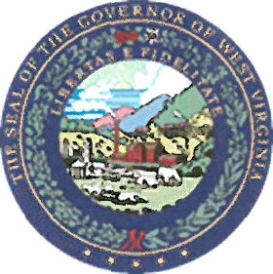

State of West Virginia Employee Acknowledgement

I agree to comply with all written directives outlined in the Governor’s Administrative Policy regarding Employee Use of Employer Provided Motor Vehicles.

I have received the training in the Fleet Management Programs. I understand that it is my responsibility to adhere to all policies regarding these programs. I also understand that it is my responsibility to observe all laws, ordinances, and rules governing the operation of a State-owned motor vehicle. I recognize if I am ever assigned a vehicle for business use, that I may be personally responsible for IRS taxes due and the IRS requires payroll tax withholding and compensation reporting (W-2) for employees using state-owned vehicles for non-business or commuting purposes.
I agree to fully complete a Vehicle Log (DOA-FM-067) each month indicating the number of business and commuting miles traveled in a State owned or leased vehicle for periods of one day or more and have used the vehicle for non-business or commuting purposes and provide it to my spending unit designee.
I understand if I do not provide the records as required, the value of all use of the automobile is considered wages to me and will appear on my W-2.

Employee Signature Date

Employee Name (Typed or Printed)

