 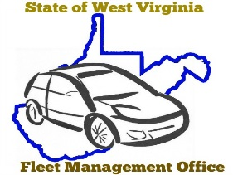

STATE OF WEST VIRGINIA

**DEPARTMENT OF ADMINISTRATION**

**FLEET MANAGEMENT DIVISION**

2310 KANAWHA BLVD, EAST

CHARLESTON, WEST VIRGINIA 25311

**DEFENSIVE DRIVING TRAINING AND DMV DRIVER’S LICENSE RECORD**

I, ___________________________________ have successfully completed either the (1) Holman

**(print Driver’s full name)**

Defensive Drivers Training Program through the Fleet Management Division or (2) an internal, department specified Defensive Driver’s Training Program. I understand that completion of either of these courses is required before I am authorized to drive a state-owned or leased vehicle and that defensive driving training be repeated on an annual basis to remain eligible. I am providing the last four digits of my social security number if a driver’s license verification is required.

I further acknowledge that a copy of my valid driver’s license and last 4 digits of my social security number will be placed in my driver file.

Any change to the status of my driver’s license must be communicated to my manager within 48 hours of the infraction.

______________________________________ __________________________

Driver Signature Date

Last Four Digits of Social Security Number

______________________________________ __________________________

Agency Fleet Coordinator Signature Date

For the documentary purpose of this record, by entering each name in the fields above, the driver and supervisor are exercising their intent to attest to the accuracy of this document.