GeoTab Key FOB Reassignment
- In GeoTab go to Administration and select Users.
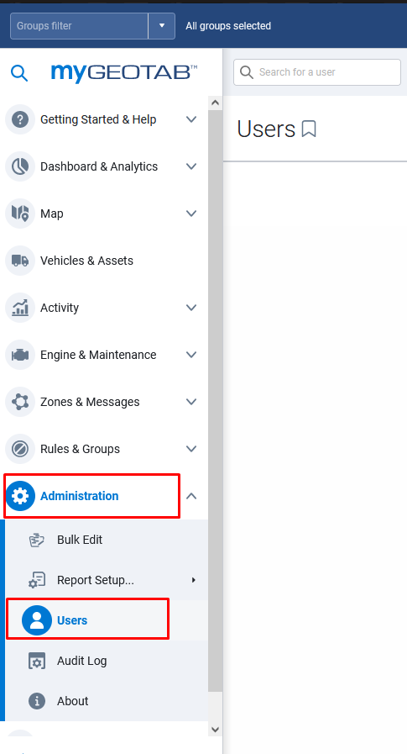
- Select the user that is no longer driving for the State of West Virginia. At the top of the screen select to Remove the user. A pop up box will appear asking you if you want to delete or Archive the user. Choose to Archive the user.
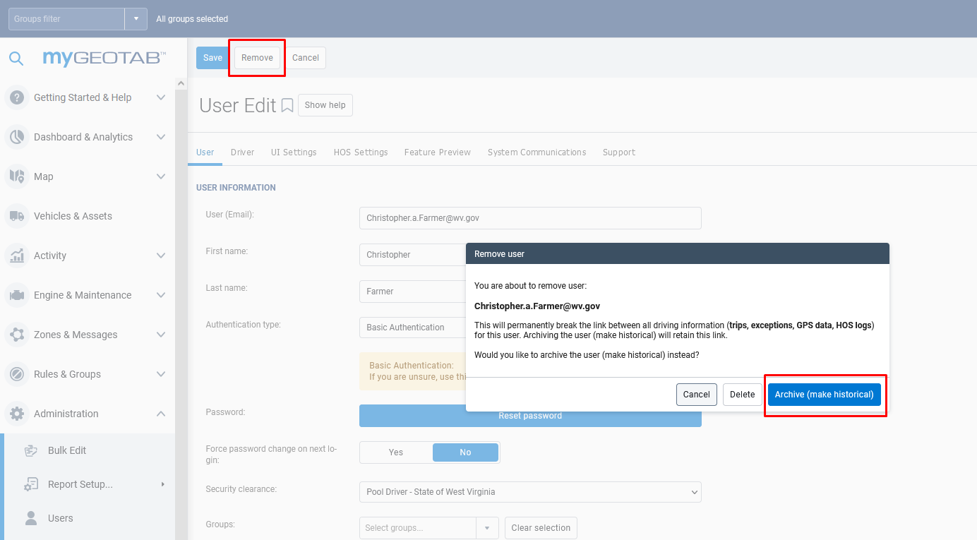

- Go back to the users listing and under the filter select Yes for Show archived and click apply changes.
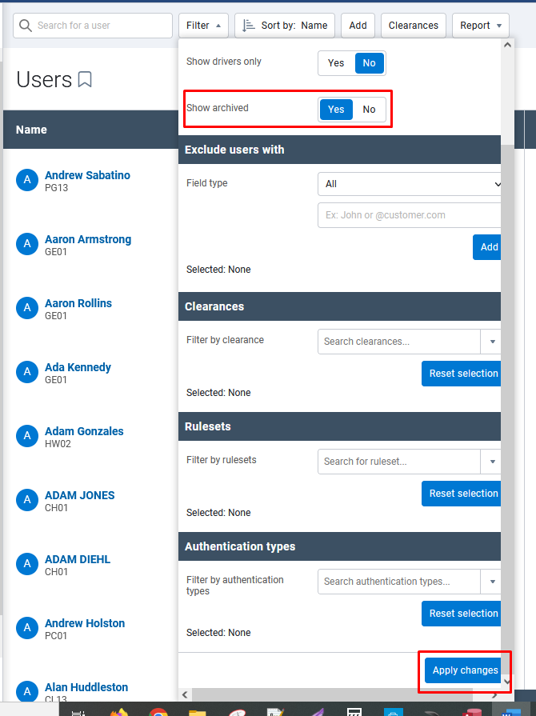

- Search for the user you just archived and select them.
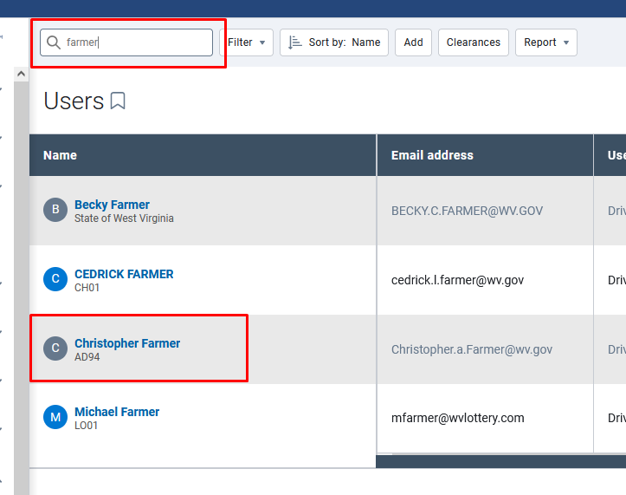

- Under the driver tab click the “X” to the right of the key FOB number to remove the FOB from the archived driver. Click save at the top left of the screen.
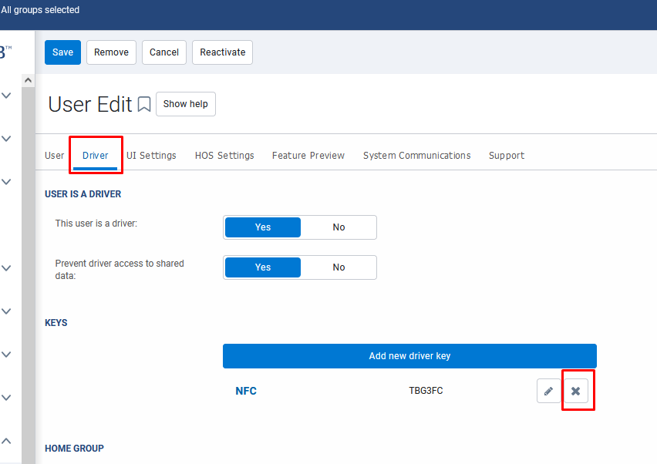

- The FOB is now removed from that user, but the user’s historical driving data will stay in the system and the FOB can now be reassigned to another individual.

